.sort ( )

By default it assumes that an array has strings as items and it sort them as per alphabetical order

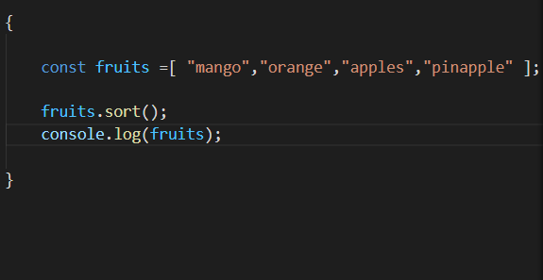

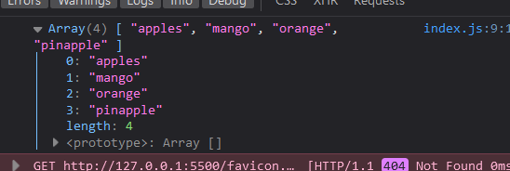

But when we have Numbers inside array

And we want to sort them in ascending order, descending order or in any random order

we can insert a compare function inside sort ( ) method

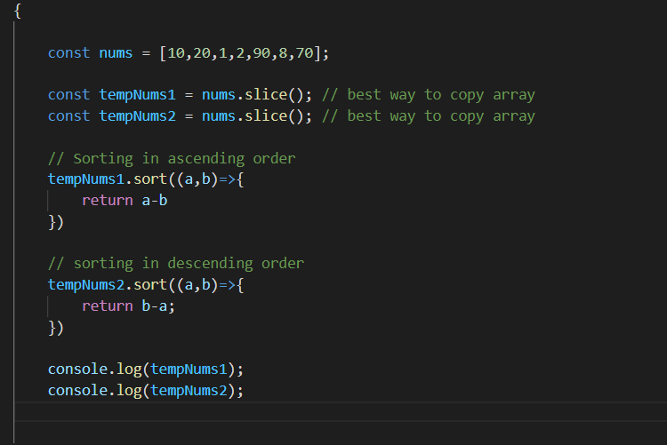

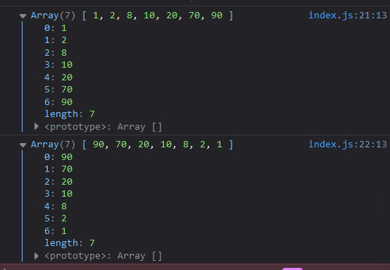

**We can even sort the arrays having objects as items using .sort ( ) method**

**Most of time arrays contains objects as items inside them**

**So this is really powerful**

**Well sorting anything is really powerful and handy**

